**SMART WATER FOUNTAINS**

**Components Needed:**

* Arduino (Tinker cad Arduino simulator).
* Ultrasonic distance sensor.
* Servo motor (for water dispensing).
* LED (for indicating system status).
* Breadboard and wires.
* Tinker cad account for simulation.

**Steps to Implement:**

**1. Automated Water Dispensing:**

Use an ultrasonic distance sensor to detect when a user approaches the fountain. When someone is within range, activate the servo motor to dispense water for a predetermined duration.

**2. IOT Connectivity**:

Simulate IoT connectivity by connecting your Arduino to Tinker cad's cloud-based platform for data logging and remote control.

**3. User-Friendly Interface:**

Design a simple user interface using Tinker cad's virtual dashboard to allow users to start and stop water flow remotely.

**4. Status Indication:**

Incorporate an LED to show the system's status (e.g., standby, dispensing, ready).

**5.Maintenance Alerts:**

Implement predictive maintenance by monitoring the fountain's components (e.g., filters, valves) and sending alerts when maintenance is required.

**6. Build the Physical Circuit:**

Set up your Arduino on Tinker cad. Connect the ultrasonic distance sensor to the Arduino to measure user proximity. Connect the servo motor to control the water flow. Add an LED to indicate system status.

**7.Code the Arduino**:

Write Arduino code to read sensor data and control the servo motor. Include logic to activate the water flow when a user is detected and stop it when the user moves away.

**8.IOT Integration:**

Use Tinker cad's cloud-based platform to create a virtual dashboard.Connect your Arduino simulation to the dashboard to send data and control commands.

**9. User Interface:**

Design a simple virtual user interface on the dashboard with start/stop buttons for water dispensing. Use virtual LEDs or status indicators to visualize system status.

**10. Testing and Refinement:**

Test your smart water fountain in the Tinker cad simulation. Debug and refine your code and circuit as needed.

**11. Documentation and Presentation:**

Create documentation explaining your project, including the circuit diagram, code, and how it works. Prepare a presentation to showcase your project to peers and educators.

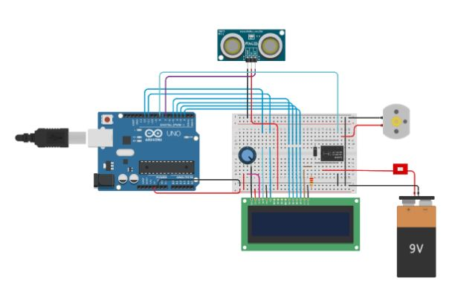

**Fig:** smart water fountains using control water flow using sensor

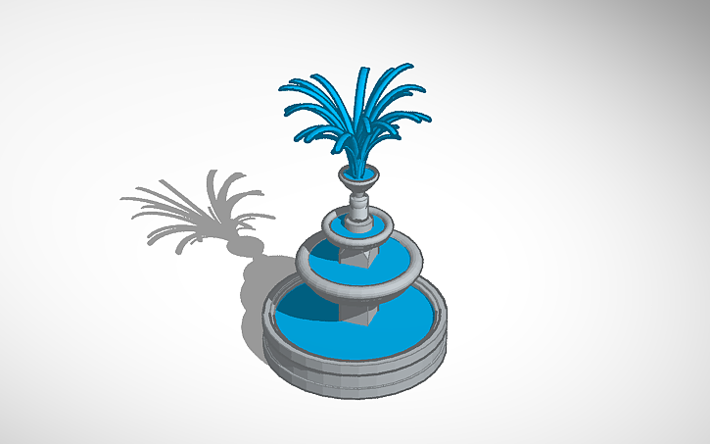

**Fig:** smart water fountain 3D design